Name –Naitik Yogi
Roll no.- 093
Branch- AI&DS
Section - b

- What is a variable in C/C++?

- A variable in C++ is a named memory location that stores a value of a specific data type, which can be used and modified during program execution.

- Why do we use variables in programs?
- We use variables in programs to store, manage, and reuse data during execution.

- What is the difference between a variable name and its value?
- A variable is a named memory location that holds data, which can be accessed and modified using its name throughout the program.
- A value is the actual data or information stored inside that variable at any given point in time.

- Which of the following is a valid variable name? a) 2num b) total_marks c) for d) my marks
- b)total_marks.

- Why is Age different from age?

- Both are variable name but as c++ is case sensitive language so both are different variable.

- Can a variable name contain spaces? Why?

- NO, a variable name can’t contain spaces because the variable name can be initialized by using alphabet letter and underscore.

- Can a variable name start with an underscore (_) ?

- Yes.

- What happens if two variables have the same name in the same scope?

- There would be error.

- Write three meaningful variable names for storing student information.

- 1.roll_no;
2.name;
3.branch;

- Which naming convention is better and why: studentMarks or sm?

- studentMarks is better because it is understandable as it directly tell that it tell the student marks without reading much programme.

- What is a data type?
-Data types form the foundation of data representation in C++. Every variable must be associated with a data type that defines the kind of value it can store and how that value is handled by the compiler.
- Data types determine the memory allocation, range of values, and operations supported by a variable.
- Understanding different data types is essential for writing correct, efficient, and maintainable C++ programs.

- Which data type is used to store whole numbers?
- int.

- Which data type is used to store decimal values?
- Float and double;

- What is the difference between float and double?
- Float and double are both used to store numbers with decimal points in programming. The key difference is their precision and storage size. A float is typically a 32-bit number with a precision of about 7 decimal digits, while a double is a 64-bit number with a precision of about 15 decimal digits. Thus, double can store larger numbers and provide more accurate calculations than float.

- Which data type stores a single character?
- Char.

- Which data type stores True/False values?
- Boolean.

- What data type is suitable for storing a person's name?
- String or array of char.

- Predict the output: int age=18; cout<<age;
- 18

- Identify the data type: 25, 3.14, 'A', true.
- Here 25 is of int .
- 3.14 is of float.
- `A` is of char.
- True is of bool.

- What happens if you store a decimal number in an int variable?
- In c++ the decimal part is removed and only integer part or whole no is left.

- What is the purpose of cin?
- cin is used to take input from user.

- What is the purpose of cout?
- Cout is used to display the output on the screen of user.

- Which symbol is used with cin?
- Symbol for cin is ’>>’.

- Which symbol is used with cout?
- Symbol for cout is ‘<<’.

- Explain: cin >> age;
- here ‘age’ is an variable of int or float data type and ‘cin>>’ is used to take input by user and it is already defined in iostream header file and ‘;’ is used to complete the statement.

- Explain: cout << age;
- Here ‘age’ is variable defined by user and ‘cout<<’ is used to print or display the output and it is defined in iostream header file ,and ‘;’ is complete the statement.

- What is the purpose of endl?
- ‘endl’ in c++ means end line and it is used to start new line after previous command.

- Write a statement to input a student's marks.
- Cin>>student_marks;

- Write a statement to display 'Welcome to C++'.
- cout<<”Welcome to C++”;

- Predict the output: cout << 'Programming';
- Programming

- What is an operator?
- C++ operators are the symbols that operate on values to perform specific mathematical or logical computations on given values.

- Which operator is used for addition?
- For addition ‘+’ operator is used.

- What is the result of 10 % 3?
- 1.

- What is the result of 8 % 2?
- 0.

- Which operator checks equality?
- For equality ‘==’ operator is used.

- What is the difference between = and == ?
- Here ‘=’ is an assignment operator which is used to assign value to the variable and ‘==’ is equality operator which is used to check equality of two values .

- What is the result of 5 > 3?
- Result is 1.

- What does && represent?
- The logical AND (&&) operator for a set of boolean operands will be true if and only if all the operands are true. Otherwise, it will be false. It's commonly used to combine conditions in conditional statements or to check multiple conditions before executing code.

- What does || represent?
- This operator is used to perform a “logical OR” operation which means the condition becomes true if any one of them is non-zero. Otherwise, it returns false

- What does ! represent?
- The ‘!’ operator represents logical NOT. It is a unary operator that inverts the Boolean value of its operand, returning true if the operand is false and false if the operand is true.

- Write a program to print 'Hello World'.

- 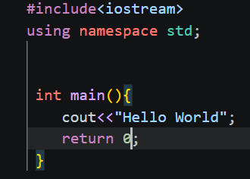

- Write a program to input two numbers and display their sum.

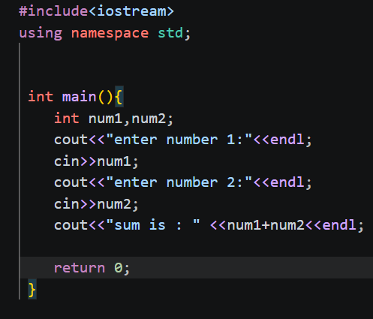

- Write a program to calculate the area of a rectangle.

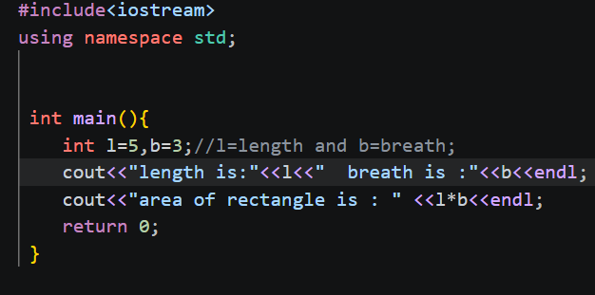

- What formula is used to calculate Simple Interest?
- SI=principle*rate*time

- Write a program to calculate Simple Interest.
- 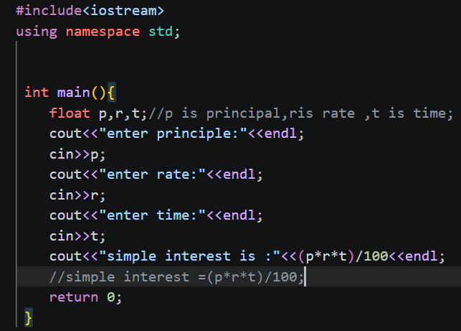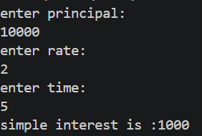
OUTPUT

- Why is a temporary variable used while swapping two numbers?
- A temporary variable is used to prevent data loss during the swap.

- Swap the values: a=10, b=20.
- 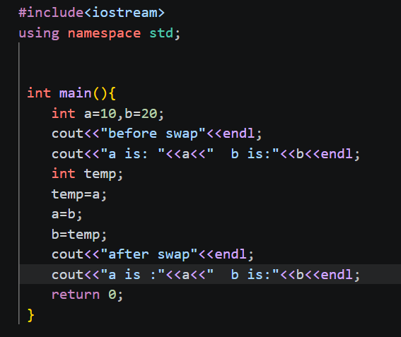
- 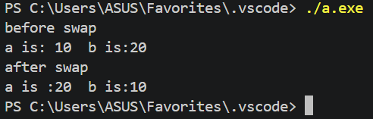
OUTPUT

- What formula is used to convert Celsius into Fahrenheit?
- F=(c*(9/5))+32.

- What is the Fahrenheit value of 0°C?
- 32℉

- Why can integer division give incorrect results in the Celsius-to-Fahrenheit program?
- Because in c++ ,if the result of 2 integer division is decimal then compiler convert decimal into integer (round off) then it does not give correct answer. Eg. result of (5/9) will be 0.

